Ala Hotel California
Functional design

Naam: Hasan Coskun
SN: 1045645
Klas: vo8e-amo1

Index
1 RESUME 2
1.1 Summary for the customer 2
1.2 Version management 2
1.3 mailing list 2
2 Programma van eisen 3
2.1 Goal 3
2.2 Current situation 3
2.3 Reason for change / adjustment 3
2.4 New situation 3
2.5 Functional requirements for the new situation 3
2.6 System requirements for the new situation 4
3 Interface 4
3.1 Interface 4
3.2 Schematics 4
4 Datamodel 5
4.1 database 5
4.2 ER Model 5
4.3 Content of the database 6
4.4 Management and security of the database 6
5 FINAL CONCLUSION 6
5.1 Accountability 6
5.2 Source acknowledgment 7

1 RESUME

1.1 Summary for the customer
This document includes the report on the functional design phase of Ala Hotel California. All main sections, as well as conclusions and recommendations, have been incorporated into this overall overview, with any references to separate, extensive documents that have been drawn up during this phase.

1.2 Version management
Version | Status | Date | Auteur | Modifications
0.1 | 1.0 | 31-5-2019 | H.Coskun | Made a mailing list, made a model, and made program requirements.

1.3 mailing list
This document is made available to:
Name | E-Mail | Phone Number | Function
Patrick van de Vries | Pvdv12@gmail.com | 06-12324567 | Project Owner
Tarik khadfy | tkhadfy@mborijnland.nl | 06-20373548 | Project Owner
Anton Prajo | aprajo@mborijnland.nl | 06-14839362 | Project Owner
Henry Robben | hrobben@mborijnland.nl | 06-02436787 | Project Owner
Edward Knoop | eknoop@mborijnland.nl | 06-10440211 | Project Owner
Jeffrey Grüne | jgrune@mborijnland.nl | 06-12456555 | Project Owner

2 Programma van eisen

2.1 Goal
The objective of functional design is good preparation for the development of a website. This is a visual description of all the functionalities of the website to be developed.
I am going to create a site where visitors can reserve rooms and that they can see the categories of different rooms and which is all available, there will also be a log in system where the visitor must write his / her data.

2.2 Current situation
Patrick van de Vries does not yet have a site for his hotel, the hotel is doing so well that all rooms are immediately full and that the reception desk is always busy with customers about reservations.
He would like the customers to do this via the site.

2.3 Reason for change / adjustment
The reason that the owner wants an application is because the customers do not always want to book at the hotel itself and the owner does not want the desk becoming busier and busier at the reception.
The good thing about the system is that customers do not have to go to the hotel to make a reservation, they save a lot of time and because they also save a lot of money.
What can be wrong is that something goes wrong with the system, for example, with the data of the customers can get mixed up or something can be forgotten with the prices of the rooms.

2.4 New situation
Is a site where customers can reserve rooms and it is done by 1 programmer.
The customer data is stored in a database

2.5 Functional requirements for the new situation

- reservation system (start / end date, type of room, number of people)
- prices of the rooms
- categories of rooms
- Contact
- the customer can see which rooms are available

2.6 System requirements for the new situation
- The set hardware and software system requirements that are required to functionally use the application:
- - Network (Wifi, Network cable)
- - Hardware requirements (Laptop, Computer, Tablet (Optional), Mobile, Router)
- - Requirements Software (Operating systems (Linux, Windows, MacOS), Microsoft office / Adobe PDF, e-mail address)

3 Interface
Hierin beschrijf je de interface tussen programma en gebruiker.

3.1 Interface
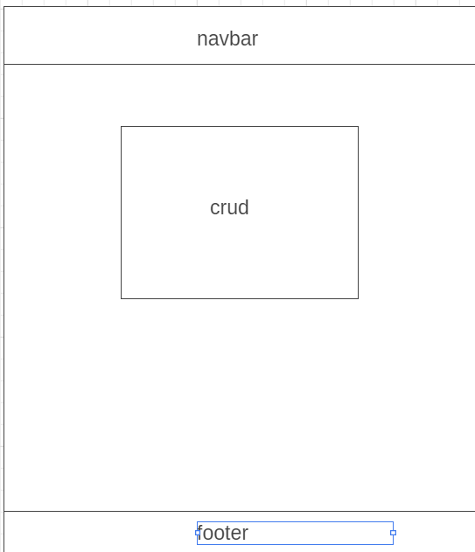

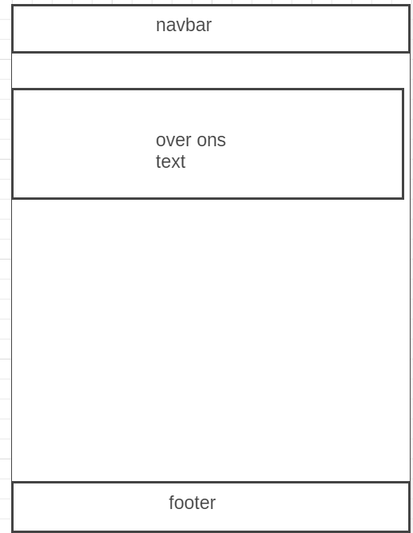
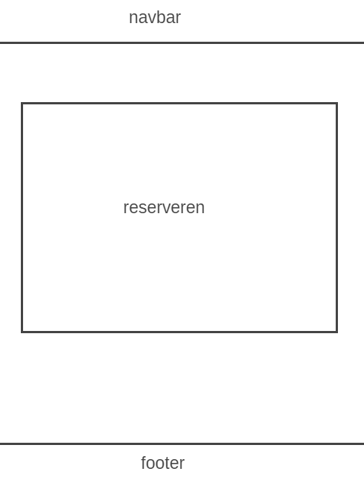

3.2 Schematics

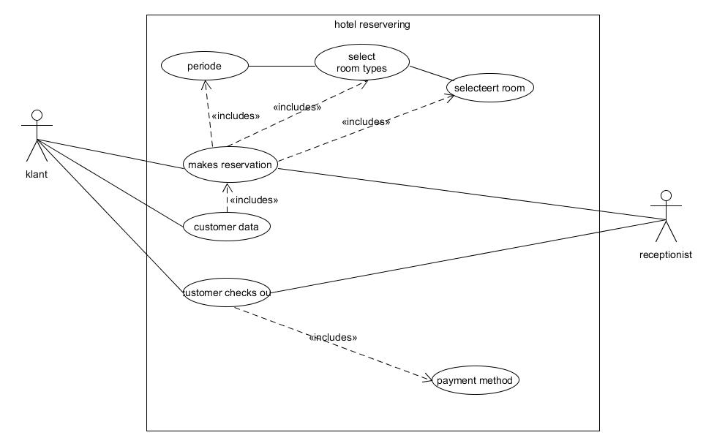
The customer can create an account to make a reservation, he also sees which rooms are available.
When the customer makes a reservation, he selects a room type, for example a double bed and then which number of the room.
The receptionist can see when the customer checked in and out.

4 Datamodel

4.1 database
Voor de database gaan wij 5 tabellen creëren. De eerste tabel die we creëren bevat de gegevens van de klant zoals zijn adresgegevens en accountgegevens.

4.2 ER Model
Table customer and reservation have a relationship that is 1 in more the primary key of table customer is customer_id. The primary key of table reservation is reser_id.
The customer can make several reservations
Between table room_availability and table reservation is 1 on more, the primary key of customer becomes the foreign key when booking and is the same with table room_availability.
.
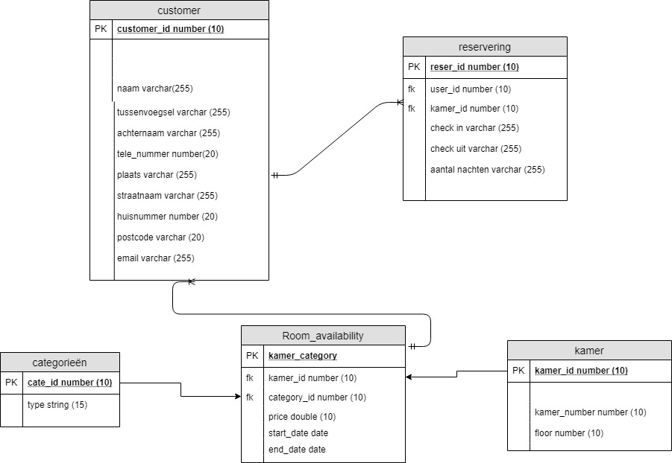

4.3 Content of the database
The database is not going to be very large and there are not going to expect many mutations, but a backup is always handy to do.

4.4 Management and security of the database

For the management of the database, I am responsible for maintaining the database. We want to ensure that the database receives a backup every 3 months, which is done manually. For the security of the database, we create two accounts that can log into the database. one for Mr. P van de Vries. and one for ourselves to arrange the backup. The account of Mr. P van de Vries access to editing and adding products. The developer's account is an admin account. All rights to edit the tables if necessary in consultation with Mr. P van de Vries.

5 FINAL CONCLUSION

5.1 Accountability

I had problems making the erd model and use case, I addressed the problem to look up and asked for help from other people

5.2 Source acknowledgment
-Plan of action
- Information requirement
- The documents from ala hotel

